**ASSIGNMENT 1 FRONT SHEET**

|  |  |  |  |
| --- | --- | --- | --- |
| **Qualification** | **TEC Level 5 HND Diploma in Computing** | | |
| **Unit number and title** | **Unit 43: Internet of Things** | | |
| **Submission date** | 11/08/2022 | **Date Received 1st submission** |  |
| **Re-submission Date** |  | **Date Received 2nd submission** |  |
| **Student Name** | Ho Minh Man | **Student ID** | GCC19247 |
| **Class** | GCC0901 | **Assessor name** | Luong Hoang Huong |
| **Student declaration**  I certify that the assignment submission is entirely my own work and I fully understand the consequences of plagiarism. I understand that making a false declaration is a form of malpractice. | | | |
|  |  | **Student’s signature** |  |

**Grading grid**

|  |  |  |  |  |  |  |  |  |  |
| --- | --- | --- | --- | --- | --- | --- | --- | --- | --- |
| P1 | P2 | P3 | P4 | M1 | M2 | M3 | M4 | D1 | D2 |
|  |  |  |  |  |  |  |  |  |  |

|  |  |  |
| --- | --- | --- |
| **❒ Summative Feedback: ❒ Resubmission Feedback:** | | |
| **Grade:** | **Assessor Signature:** | **Date:** |
| **Internal Verifier’s Comments:** | | |
| **Signature & Date:** | | |

# Assignment Brief 1 (RQF)

## Higher National Certificate/Diploma in Business

|  |  |
| --- | --- |
| **Student Name/ID Number:** |  |
| **Unit Number and Title:** | **Unit 43 – Internet of Things** |
| **Academic Year:** | **2021** |
| **Unit Assessor:** | **Tran Trong Minh** |
| **Assignment Title:** | **Assignment 1 – Internet of Things** |
| **Issue Date:** |  |
| **Submission Date:** |  |
| **Internal Verifier Name:** |  |
| **Date:** |  |

|  |
| --- |
| **Submission Format:** |
| *Format:* This assignment is an Individual assignment and specifically including 1 document:  You must use font *Calibri size 12, set number of the pages and use multiple line spacing at 1.3. Margins must be: left: 1.25 cm; right: 1 cm; top: 1 cm and bottom: 1 cm.* The reference follows Harvard referencing system. The recommended word limit is *2.000-2.500 words*. You will not be penalized for exceeding the total word limit. The cover page of the report has to be the Assignment front sheet 1.  *Submission* Students are compulsory to submit the assignment in due date and in a way requested by the Tutors. The form of submission will be a soft copy posted on <http://cms.greenwich.edu.vn/>  *Note:* The Assignment *must* be your own work, and not copied by or from another student or from  books etc. If you use ideas, quotes or data (such as diagrams) from books, journals or other sources, you must reference your sources, using the Harvard style. Make sure that you know how to reference properly, and that understand the guidelines on plagiarism. *If you do not, you definitely get fail* |
| **Unit Learning Outcomes:** |
| **LO1** Analyse what aspects of IoT are necessary and appropriate when designing software applications  **LO2** Outline a plan for an appropriate IoT application using common architecture, frameworks, tools, hardware and APIs  **LO3** Develop an IoT application using any combination of hardware, software, data, platforms and services.  **LO4** Evaluate your IoT application and detail the problem your IoT application solves, the potential impact on people, business, society and the end user and the problems it might encounter when integrating into the wider IoT ecosystem |
| **Assignment Brief and Guidance:** |
| You currently work as a product developer for a new startup where you design IoT products for the consumer, corporate, government and defence clients. As part of your role your manager has tasked you to plan and develop a new IoT product, service or application for a potential client. You are required to identify a target user and conduct tests with this user and include this feedback into multiple iterative versions of your product.  **Part 1 (Assignment 1)**:: For the first part, you must:   * Plan an IoT application for a specific target end user and the tests you intend to conduct with this user. This plan will be in the form of a document and will include supporting evidence and material, such as user personas and customer journey maps. * Create multiple iterations of your application and modify each iteration with enhancements gathered from user feedback and experimentation. This will follow the pathway outlined in your plan.(log book,)   **Part 2 (Assignment 2)**: For the first part, you must:   * Show evidence about Developed IoT application using any combination of hardware, software, data, platforms and services (video or images of your IoT system with code snippet) * Evaluate your IoT application and detail the problem your IoT application solves, the potential impact on people, business, society and the end user and the problems it might encounter when integrating into the wider IoT ecosystem |

|  |  |  |
| --- | --- | --- |
| Learning Outcomes and Assessment Criteria | | |
| Pass | Merit | Distinction |
| **LO1** Analyse what aspects of IoT are necessary and appropriate when designing software applications | | |
| **P1** Explore various forms of IoT functionality.  **P2** Review standard architecture, frameworks, tools, hardware and APIs available for use in IoT development. | **M1** Evaluate the impact of common IoT architecture, frameworks, tools, hardware and APIs in the software development lifecycle.  **M2** Evaluate the impact of common IoT architecture, frameworks, tools, hardware and APIs in IoT security. | **D1** Evaluate specific forms of IoT architecture and justify their usage when designing software applications. |
| **LO2** Outline a plan for an appropriate IoT application using common architecture, frameworks, tools, hardware and APIs | | |
| **P3** Investigate architecture, frameworks, tools, hardware and API techniques available to develop IoT applications.  **P4** Determine a specific problem to solve using IoT. | **M3** Select the most appropriate IoT architecture, frameworks, tools, hardware and API techniques to include in an application to solve this problem.  **M4** Apply your selected techniques to create an IoT application development plan. | **D2** Make multiple iterations plan of your IoT application and modify each iteration to improve your IoT application security. |

Contents

Assignment Brief 1 (RQF) 3

Higher National Certificate/Diploma in Business 3

**I.** **Task 1 – Review and evaluate about IoT aspects.** 8

**Review IoT functionality, standard architecture, frameworks, tools, hardware and APIs** 8

**1. Definition about IoT:** 8

**2. How does IoT work?** 9

3. Applications of IoT 11

4. Characteristics of the Internet of Things : 12

5. Some examples for real world application of IoT 14

Task 2 – Plan an appropriate IoT application 19

II. Introduce almost standard architectures, frameworks, tools, hardware and APIs that are available for using in IoT development: 19

1.What are IoT architecture: 19

2. Iot Frameworks: 26

3. IoT Hardware: 29

4. IoT APIs: 31

5. IoT Tools 34

Determine a prolem and IoT solution: 36

**1.** **Scenario:** Temperature and humidity, and Light diagnosis based on IoTs. 36

**2.** **Solution:** 36

**3.** **System and function diagram:** 37

References 43

**Table Of Figure**

Figure 1 Iot for Healcare 13

Figure 2 IoT for Industrial 14

Figure 3 Smart City and IoT 15

Figure 4 Smart Rail and IoT 16

Figure 5 IoT applications in farming 17

Figure 6 IoT architecture 18

Figure 7 IoT architecture building blocks 19

Figure 8 Things, sensors and controllers 20

Figure 9 Gateways and data acquisition 21

Figure 10 Edge analytics 22

Figure 11 Data centre / Cloud platform 23

Figure 12 5 Layer IoT 24

Figure 13 IoT Frameworks 25

Figure 14 Framework 35

Figure 15 System Diagram 35

Figure 16 Ardunio Uno R3 36

Figure 17 LCD 1602 37

Figure 18 Real-time module DS1302 38

Figure 19 RFID NFC Circuit 39

Figure 20 IR Variant Sensor IR Obstacle Avoidance 40

Figure 21 Loadcell Sensor 1Kg 41

Figure 22 Servo RC Motor 9G 42

1. **Task 1 – Review and evaluate about IoT aspects.**

**Review IoT functionality, standard architecture, frameworks, tools, hardware and APIs**

**1. Definition about IoT:**

The Internet of Things, or IoT, refers to the billions of physical devices around the world that are now connected to the internet, all collecting and sharing data. Thanks to the arrival of super-cheap computer chips and the ubiquity of wireless networks, it's possible to turn anything, from something as small as a pill to something as big as an aeroplane, into a part of the IoT. Connecting up all these different objects and adding sensors to them adds a level of digital intelligence to devices that would be otherwise dumb, enabling them to communicate real-time data without involving a human being. The Internet of Things is making the fabric of the world around us smarter and more responsive, merging the digital and physical universes**.**

(Ranger, 2020)

**Example of an Internet of Things device:**

A lightbulb that can be switched on using a smartphone app is an IoT device, as is a motion sensor or a smart thermostat in your office or a connected streetlight. Some larger objects may themselves be filled with many smaller IoT components, such as a jet engine that's now filled with thousands of sensors collecting and transmitting data back to make sure it is operating efficiently. At an even bigger scale, smart cities projects are filling entire regions with sensors to help us understand and control the environment.

(Ranger, 2020)

**Understanding about IoT functionality, standard architecture, frameworks, tools, hardware and APIs**

* **IoT frameworks**: The IoT framework is what makes it possible for connected devices to communicate smoothly over the Internet. It is therefore not uncommon for it to be called the 'Internet of Things' framework, or in other words, the framework that facilitates the interaction of 'Things' (devices) over the Internet.
* **4 Stage IoT architecture:** 
  + **Sensing Layer:** Sensors, actuators, devices are present in this Sensing layer. These Sensors or Actuators accepts data (physical/environmental parameters), processes data and emits data over network.
  + **Network Layer**: Internet/Network gateways, Data Acquisition System (DAS) are present in this layer. DAS performs data aggregation and conversion function (Collecting data and aggregating data then converting analog data of sensors to digital data etc). Advanced gateways which mainly opens up connection between Sensor networks and Internet also performs many basic gateway functionalities like malware protection, and filtering also sometimes decision making based on inputted data and data management services, etc.
  + **Data processing Layer**: This is processing unit of IoT ecosystem. Here data is analyzed and pre-processed before sending it to data center from where data is accessed by software applications often termed as business applications where data is monitored and managed and further actions are also prepared. So here Edge IT or edge analytics comes into picture.
  + **Application Layer**: This is last layer of 4 stages of IoT architecture. Data centers or cloud is management stage of data where data is managed and is used by end-user applications like agriculture, health care, aerospace, farming, defense, etc.

(geeksforgeeks, 2020)

* **IoT Tools**: It is a network or connection of devices, vehicles, equipment applying embedded electronics, home appliances, buildings and many more. This helps in collecting and exchanging different kinds of data. It also helps the user to control the devices remotely over a network.

Some IoT tools: Eclipse IoT, Arduino, Platform IoT, Net, etc.

(Pedamkar, 2020)

* **IoT Hardware:** IoT Hardware includes a wide range of devices such as devices for routing, bridges, sensors etc. These IoT devices manage key tasks and functions such as system activation, security, action specifications, communication, and detection of support-specific goals and actions.
* **IoT APIs:** APIs are a set of requirements that determine exactly how applications can talk to each other. APIs have been around for many years; whenever you use your everyday computer or smartphone, APIs make it possible to transfer information between programs such as copying and pasting from one application to another, which is done using a system-level API in the OS.

On the web, APIs allow big everyday services such as Google maps, Facebook or twitter to integrate with other applications features. Take a moment and think about the way TripAdvisor works, by displaying local hotels, restaurants and attractions on a google map using its own web data, or mobile games that allow users to invite their friends through Facebook or Google+**.**

(Maker.io, 2016)

**2. How does IoT work?**

An IoT ecosystem consists of web-enabled smart devices that use embedded systems, such as processors, sensors and communication hardware, to collect, send and act on data they acquire from their environments. IoT devices share the sensor data they collect by connecting to an IoT gateway or other edge device where data is either sent to the cloud to be analyzed or analyzed locally. Sometimes, these devices communicate with other related devices and act on the information they get from one another. The devices do most of the work without human intervention, although people can interact with the devices -- for instance, to set them up, give them instructions or access the data.

The connectivity, networking and communication protocols used with these web-enabled devices largely depend on the specific IoT applications deployed.

IoT can also make use of artificial intelligence (AI) and machine learning to aid in making data collecting processes easier and more dynamic.

(Gillis, 2020)

The “things” that make up the IoT can be anything from a wearable fitness tracker to an autonomous vehicle. No matter what function they serve for users, these devices must have the following components for them to properly operate as parts of their respective IoT systems.

**Sensors**. Data is first collected from the environment for the IoT system to begin processing. It is collected by sensors in devices that can measure observable occurrences or changes in the environment. The kind of data being measured by the device depends on its function: It can be a person’s pulse in the case of a fitness tracker or the distance of the nearest object in that of an autonomous vehicle.

**Connection and identification**. The data must be communicated from the device to the rest of the IoT system, be it to a computer or to another device. And for this communication to have any meaning, a device must have a unique identifiable presence on the internet, accomplished through its own IP address.

**Actuators**. Most IoT devices are capable of doing their primary functions without physical interaction with their users. IoT devices should be able to take action based on data from their sensors and the subsequent feedback from the network. A smart lightbulb, for example, can turn on upon the command of its user, even when the user is miles away. In the same manner, a valve in a smart factory can automatically open or close according to data gathered by its sensors along the production line.

Even though the devices are usually built with automation in mind, other technologies must be in place for IoT systems to work. Completing the links of how IoT systems process data are the following components.

**IoT gateway**. The IoT gateway acts as a bridge for the different devices’ data to reach the cloud. It also helps in translating the different protocols of the various IoT devices into just one standard protocol and in filtering out unnecessary data gathered by the devices.

**The cloud**. The cloud is where all the data from the different devices is gathered and where software can reach this data for processing. Because most of data processing happens in the cloud, it lessens the burden on individual devices.

**User interface**. The user interface communicates to the users the data gathered by the devices and allows the users to make the necessary commands to be executed by the devices.

The Internet Architecture Board released a guiding document that outlines the four communication channels used by the IoT. The four models also demonstrate how the connectivity of IoT devices helps extend the value of each device and adds quality to the overall user experience:

**Device-to-Device**. This model represents how two or more devices connect and communicate directly with one another. Communication between devices is usually achieved through protocols such as Bluetooth, Z-Wave and Zigbee. This model is often found in in wearables and in home automation devices, where small packets of data are communicated from one device to another, as with a door lock to a lightbulb.

**Device-to-Cloud.** Many IoT devices connect to the cloud, often with the use of wired Ethernet or Wi-Fi. Connecting to the cloud allows users and related applications to access the devices, making it possible to course through commands remotely as well as push necessary updates to the device software. Through this connection, the devices can also collect user data for the improvement of their service providers.

**Device-to-Gateway**. Before connecting to the cloud, IoT devices can communicate first with an intermediary gateway device. The gateway can translate protocols and add an additional layer of security for the entire IoT system. In the case of a smart home, for example, all smart devices can be connected to a hub (the gateway) that helps the different devices to work together despite having different connection protocols.

**Back-End Data-Sharing**. An extension of the device-to-cloud model, this model allows users to gain access to and analyze a collection of data from different smart devices. A company, for instance, can use this model to access information from all of the devices working inside the company building as organized together in the cloud. This model also helps lessen issues with data portability.

(trendmicro.com, 2021)

## 3. Applications of IoT

**Infrastructure management:** IoT and the important application of IoT is infrastructure management, IoT can monitor and control the activities of urban and rural infrastructure such as bridges, train tracks and farms, etc. can be used to monitor any events or changes in structural conditions that could affect the safety and danger of the infrastructure. It can be used to efficiently plan repair and maintenance operations.

**Smart traffic:** IoT products can assist in the integration of communication, control and information processing across multiple transportation systems. The application of IoT extends to all aspects of the transportation system, vehicle, infrastructure, and driver use. Interactions between the components of a transportation system enable intelligent traffic control, smart parking, electronic toll collection systems, fleet management, safety and road assistance. From connected cars to self-driving cars to intelligent transportation and logistics systems IoT can save lives and reduce traffic and reduce vehicle impact on the environment. Or applied to it can include the light poles on both sides of the road, it can sense, can identify day and night to turn on and off the lights in the most reasonable way.

**Construction and home automation:** With IoT devices can be used in many types of buildings. Automation systems such as the system automation are commonly used conditions for lighting, heating, ventilation, air conditioning, equipment, communication systems, entertainment and security equipment, home to enhance convenience, comfort, energy efficiency and security.For example, a product developed by LifeSmart is used to control lighting, home appliances and many other devices.

**IoT in medicine:** IoT devices can be used to enable remote health monitoring and error reporting. Health monitoring devices can measure blood pressure and time rhythm with advanced devices that have special monitoring capabilities, not limited to pacemakers or support advanced procedures. In particular, sensors can also be equipped in living spaces to monitor the health of the elderly. Regarding medical IoT applications, there are smart bracelets that help monitor users' health such as heart rate measurement, blood glucose monitoring, blood glucose testing, hydration detection and many different functions.

**IoT in agriculture:** With IoT devices that can assist farmers in monitoring parameters of temperature, air humidity, pressure, light, wind, rain and soil moisture, etc., helping farmers reduce time labor, increase crop productivity.

## 4. Characteristics of the Internet of Things :

**There are the following characteristics of IoT as follows:**

**Connectivity:** Connectivity is an important requirement of the IoT infrastructure. Things of IoT should be connected to the IoT infrastructure. Anyone, anywhere, anytime can connectivity should be guaranteed at all times Without connection, nothing makes sense.

**Intelligence and Identity:** The extraction of knowledge from the generated data is very important. For example, a sensor generates data, but that data will only be useful if it is interpreted properly. Each IoT device has a unique identity. This identification is helpful in tracking the equipment and at times for querying its status.

**Scalability:** The number of elements connected to the IoT zone is increasing day by day. Hence, an IoT setup should be capable of handling the massive expansion. The data generated as an outcome is enormous, and it should be handled appropriately.

**Dynamic and Self-Adapting (Complexity):** IoT devices should dynamically adapt themselves to the changing contexts and scenarios. Assume a camera meant for the surveillance. It should be adaptable to work in different conditions and different light situations (morning, afternoon, night).

**Architecture:** IoT architecture cannot be homogeneous in nature. It should be hybrid, supporting different manufacturers ‘ products to function in the IoT network. IoT is not owned by anyone engineering branch. IoT is a reality when multiple domains come together.

**Action**: The consequence of intelligence. This can be manual action, action based upon debates regarding phenomena (for instance in smart factory decisions) and automation, often the most important piece.

**Safety:** There is a danger of the sensitive personal details of the users getting compromised when all his/her devices are connected to the internet. This can cause a loss to the user. Hence, data security is the major challenge. Besides, the equipment involved is huge. IoT networks may also be at the risk. Therefore, equipment safety is also critical**.**

(geeksforgeeks, 2021)

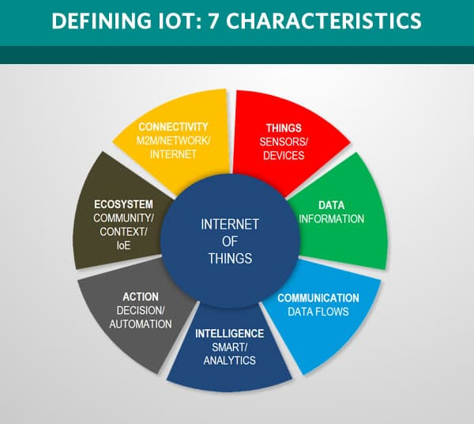

Figure 1 Characteristics**[1]**

## 5. Some examples for real world application of IoT

**Healthcare**: IoT deals with healthcare through its connection mechanisms. Devices like smartwatches or fitness bands or stress detectors are a great example of IoT applications that involve the welfare of the public.

Other smart medical devices used in companies lead to a better healthcare system too. An individual’s health and the ways to improve it are all known to them via these healthcare devices. The base for this application is IoT’s ability to connect devices, collect data through sensors, and analyze them to form the right results.

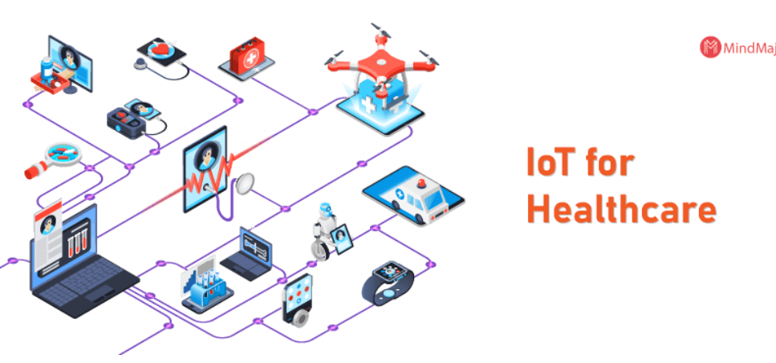

Figure 2 Iot for Healcare[2]

**Industrial Use**: As the name suggests, this application deals mostly with the industrial sector than the personal sector. IoT applications deal with developing the industry and it's working methods with the help of software used for data analysis, sensors, tracking devices, and machines that are effective and masterly.

These help a firm to have accurate, enhanced, and transparent functioning. One can not only improve things but can also identify the damaged spots for an accurate cure. When IoT is used in industries, a sustainable approach is well-established.

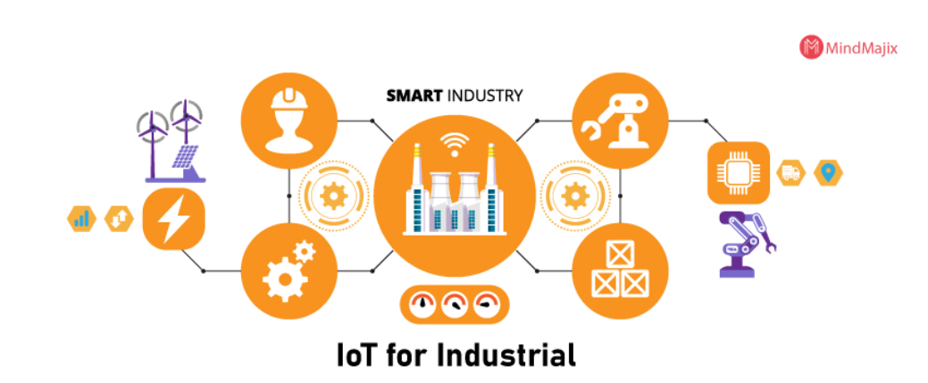

Figure 3 IoT for Industrial

**Smart city:** Smart city is an application of IoT that creates curiosity of many people. Smart monitoring, automated transportation, smarter energy management systems, water distribution, urban security and environmental monitoring are all examples of the internet of applications for smart cities. IoT helps to solve the problems encountered in big cities such as environmental pollution, traffic congestion and lack of energy. An example can be mentioned of devices that use mobile communication such as: smart trash cans, which will send an alert to the sanitation department when it needs to be cleaned.

By installing the application and using smart devices, we can easily find gas stations, supermarkets, restaurants or even free parking lots. In addition, the electrical system is also protected by sensors that will quickly detect interference, malfunction, or installation problems.

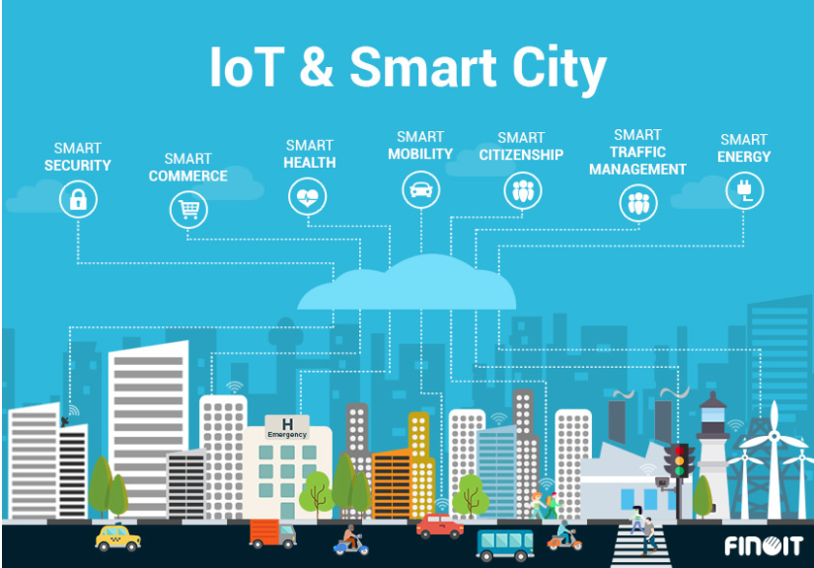

Figure 4 Smart City and IoT**[3]**

**Retail Purpose:**

Retailing is all about connecting with the consumers on a more personal level and IoT enables a retailer to stay connected with their consumers with the help of their smartphones.Through this connection, the retailers get real feedback from their consumers and also helps them find the demand in their particular place in order to change their goods supply accordingly. On the whole, the overall in-store experience is enhanced to meet the needs of their prospective customers, goods are advertised effectively, and the supply chains are well maintained. Even payment procedures are enhanced.

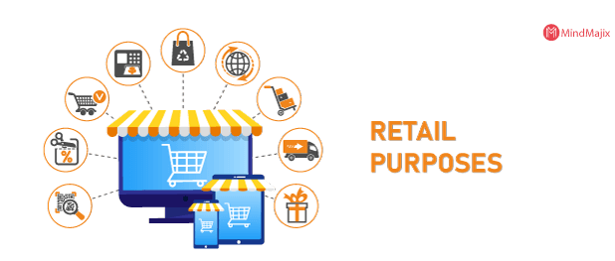

Figure 5 Retail Purposes[4]

**IoT applications in farming:** If before, the whole farming process depended heavily on human labor, now it can be completely simplified with the appearance of machines and technology.

The appearance of machines will reduce the cost of environmental protection. With the cultivation process from planting to tending or harvesting, the application of machines brings remarkable results.

When applying IoT to farming, we can completely control the necessary information for the growth of plants, such as: soil nutrition, suitable fertilizer amount, humidity of the air. as well as soil moisture,...to be able to have an accurate and economical care plan. Or simply when plants encounter diseases thanks to IoT, we can detect diseases early and control the spread as well as have the most accurate treatment plan. Thanks to the process of the machines working, the growth process of the tree is analyzed regularly. An extremely important issue here is: if before you could not be sure about the content of pesticides or food protection drugs in the vegetables on the market, now you can completely quit. Those worries are left behind, because when applying IoT to farming, the amount of toxic substances absorbed by plants is always controlled and safe. Applying the innovation of IoT to farming will certainly significantly increase the yield as well as reduce the investment costs of planting as well as the costs of crop condition analysis activities.

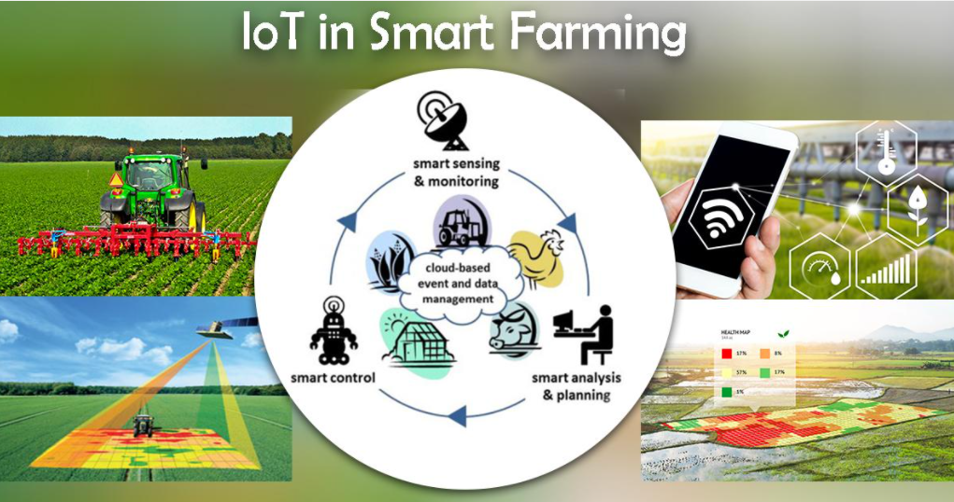

Figure 6 IoT applications in farming[5]

# Task 2 – Plan an appropriate IoT application

# II. Introduce almost standard architectures, frameworks, tools, hardware and APIs that are available for using in IoT development:

## 1.What are IoT architecture:

Due to the ever-evolving nature of IoT devices, and the wide diversity of sensors, there is no one-size-fits-all architecture for IoT projects. However, some of the building blocks will be similar from project to project.

First, you will need to build with scalability in mind. The amount of data that you will collect over time will take on enormous proportions and you will need a platform that can accommodate this in the long run.

You will also need to ensure that you have high availability at any given time. Having system failures could make you lose some business in the best case, or could have fatal consequences in the worst cases.

Finally, you will need a system that is flexible enough to accommodate quick and frequent changes. As your architecture evolves, or your business needs change, you will need to iterate quickly without breaking the existing architecture.IoT architecture building blocks

**IoT architecture building blocks**

While every IoT system is different, the foundation for each Internet of Things architecture as well as its general data process flow is roughly the same. First of all, it consists of the Things, which are objects connected to the Internet which by means of their embedded sensors and actuators are able to sense the environment around them and gather information that is then passed on to IoT gateways. The next stage consists of IoT data acquisition systems and gateways that collect the great mass of unprocessed data, convert it into digital streams, filter and pre-process it so that it is ready for analysis. The third layer is represented by edge devices responsible for further processing and enhanced analysis of data. This layer is also where visualisation and machine learning technologies may step in. After that, the data is transferred to data centres which can be either cloud-based or installed locally. This is where the data is stored, managed and analysed in depth for actionable insights.

(avsystem, 2019)

These are the four layers of IoT architecture described in detail:

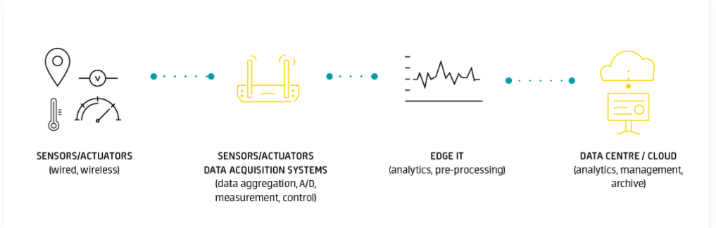

Figure 7 IoT architecture building blocks[6]

**Things, sensors and controllers**

As the basis for every IoT system, connected devices are responsible for providing the essence of the Internet of Things which is the data. To pick up physical parameters in the outside world or within the object itself, they need sensors. These can be either embedded in the devices themselves or implemented as standalone objects to measure and collect telemetry data. For an example, think of agricultural sensors whose task is to measure parameters such as air and soil temperature and humidity, soil pH levels or crop exposure to sunlight.

Another indispensable element of this layer are the actuators. Being in close collaboration with the sensors, they can transform the data generated by smart objects into physical action. Let’s imagine a smart watering system with all the necessary sensors in place. Based on the input provided by the sensors, the system analyses the situation in real time and commands the actuators to open selected water valves located in places where soil humidity is below the set value. The valves are kept open until the sensors report that the values are restored to default. Obviously, all of this happens without a single human intervention.

What is also important is that the connected objects should not only be capable of communicating bidirectionally with their corresponding gateways or data acquisition systems, but also being able to recognise and talk to each other to gather and share information and collaborate in real time to leverage the value of the whole deployment. In case of resource-constrained and battery-operated devices particularly, achieving this is not an easy task since such communication requires lots of computing power and consumes precious energy and bandwidth. Therefore, a robust architecture can only enable effective device management when it uses fit-for-purpose, secure and lightweight communication protocols, such as Lightweight M2M which has become a leading standard protocol for the management of low power lightweight devices which are typical for many IoT use cases

(avsystem, 2019)

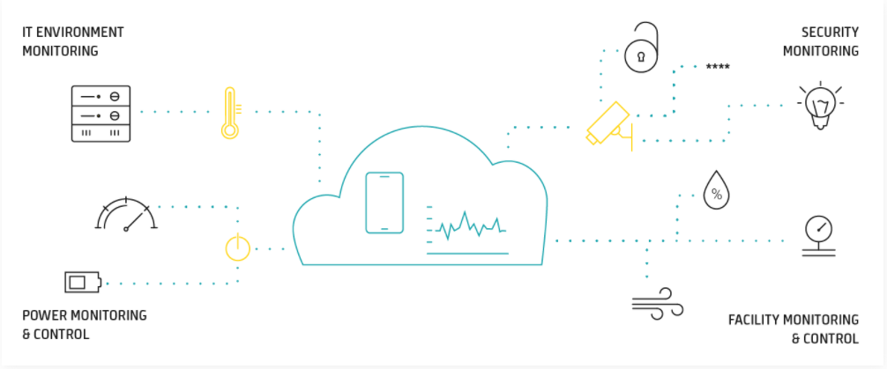

Figure 8 Things, sensors and controllers

**Gateways and data acquisition**

Although this layer still functions in close proximity with sensors and actuators on given devices, it is essential to describe it as a separate IoT architecture stage as it is crucial for the processes of data collection, filtering and transfer to edge infrastructure and cloud-based platforms. Given the massive volume of input and output that million-device deployments may generate, capabilities for the aggregation, selection and transportation of data should be in the spotlight. As intermediaries between the connected things and the cloud and analytics, gateways and data acquisition systems provide the necessary connection point that ties the remaining layers together.

Sitting at the verge of the worlds of OT and IT, gateways facilitate communication between the sensors and the rest of the system by converting the sensor data into formats that are easily transferable and usable for other system components down the line. What’s more, they are able to control, filter and select data to minimise the volume of information that needs to be forwarded to the cloud, which positively affects network transmission costs and response times. Thus, gateways provide a place for the local preprocessing of sensor data which is squeezed into useful bundles ready for further processing.

Another aspect that the gateways support is security. Because the gateways are responsible for managing the information flow in both directions, with the help of proper encryption and security tools they can prevent IoT cloud data leaks as well as reduce the risk of malicious outside attacks on IoT devices.

(avsystem, 2019)

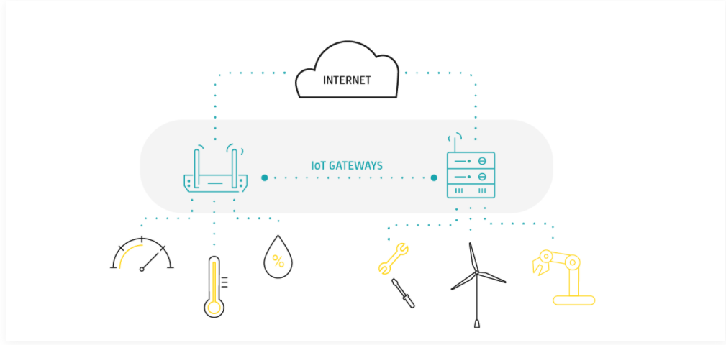

Figure 9 Gateways and data acquisition

**Edge analytics**

While not being an inevitable component of every IoT architecture, edge devices can bring significant benefits especially to large-scale IoT projects. In the face of limited accessibility and data transfer speed of the IoT cloud platforms, edge systems can provide quicker response times and more flexibility in the processing and analysis of IoT data. As speed of data analysis is key in some Industrial Internet of Things applications, edge computing has recently seen a dramatic increase in popularity among Industrial Internet of Things ecosystems.

As edge infrastructure can be located closer to the data source in physical terms, it is easier and quicker for it to act on the IoT material in real time and provide output in the form of instant actionable intelligence. In this scenario, only the larger chunks of data which really need the power of the Cloud to be processed are forwarded there. By minimizing network exposure, security can be significantly enhanced, while reduced power and bandwidth consumption contributes to more efficient leveraging of business resources.

(avsystem, 2019)

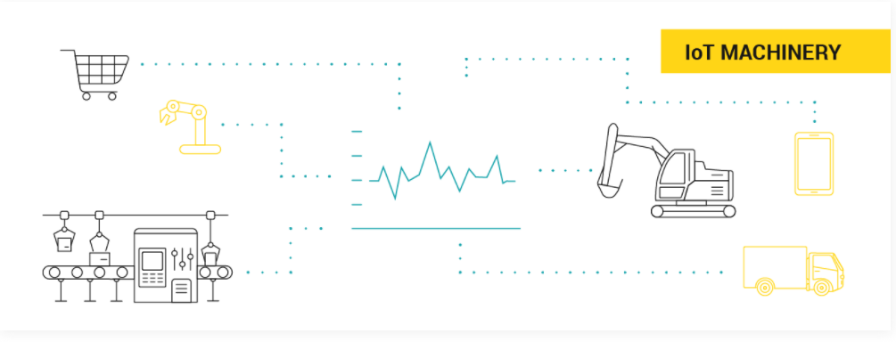

Figure 10 Edge analytics

**Data centre / Cloud platform**

If sensors are neurons and the gateway is the backbone of IoT, then the cloud is the brain in the Internet of Things body. Contrary to edge solutions, a data centre or a cloud-based system is designed to store, process and analyse massive volumes of data for deeper insights using powerful data analytics engines and machine learning mechanisms which edge systems would never be able to support.

Having seen increased adoption (especially in Industrial IoT architecture) over the past several years, cloud computing contributes to higher production rates, reduction of unplanned downtime and energy consumption and many other business benefits.

If furnished with proper user application solutions, the cloud can provide business intelligence and presentation options that help humans interact with the system, control and monitor it and make informed decisions on the basis of reports, dashboards and data viewed in real time.

(avsystem, 2019)

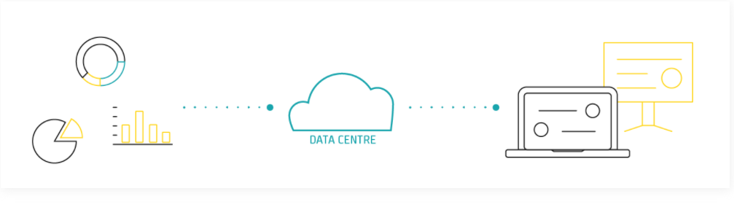

Figure 11 Data centre / Cloud platform

**5 Layer Architecture of Internet of Things**

Internet of Things (IoT) includes large number of smart devices connected to a broad internet network with the help of various networking technologies. Mostly these technologies are wireless in manner. This makes the structure more complex and difficult to manage. Therefore, architecture is required.

An architecture is structure for specification of network’s physical components and their functional organization and configuration, its operational principles and procedures, as well as data formats used in its operation.

The development of IoT depends on the technologies used, application areas, and business aspects. There are various IoT architectures are available for IoT devices. However, the “5 Layer Architecture is considered as the best-proposed architecture of IoT.”

(geeksforgeeks, 2021)

**5 Layer Architecture**

**Perception Layer** : This is the first layer of IoT architecture. In the perception layer, number of sensors and actuators are used to gather useful information like temperature, moisture content, intruder detection, sounds, etc. The main function of this layer is to get information from surroundings and to pass data to another layer so that some actions can be done based on that information.

**Network Layer** : As the name suggests, it is the connecting layer between perception and middleware layer. It gets data from perception layer and passes data to middleware layer using networking technologies like 3G, 4G, UTMS, WiFI, infrared, etc. This is also called communication layer because it is responsible for communication between perception and middleware layer. All the transfer of data done securely keeping the obtained data confidential.

**Middleware Layer:** Middleware Layer has some advanced features like storage, computation, processing, action taking capabilities. It stores all data-set and based on the device address and name it gives appropriate data to that device. It can also take decisions based on calculations done on data-set obtained from sensors.

**Application Layer:** The application layer manages all application process based on information obtained from middleware layer. This application involves sending emails, activating alarm, security system, turn on or off a device, smartwatch, smart agriculture, etc.

**Business Layer:** The success of any device does not depend only on technologies used in it but also how it is being delivered to its consumers. Business layer does these tasks for the device. It involves making flowcharts, graphs, analysis of results, and how device can be improved, etc.

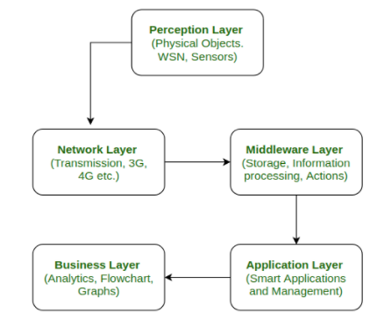

Figure 12 5 Layer IoT[7]

## 2. Iot Frameworks:

This specific point is very essential in a network, as it combines all data, making it possible to understand the data being generated.

However, the smooth transmission and generation of data don’t just happen. Rather, it is usually made possible by the Internet of Things Framework, (IoT framework). So, just what is IoT framework?

The Internet of Things (IoT) Framework can be described as being an ecosystem, comprising of several connected devices that communicate with each other, over the Internet. These connected devices usually work to transfer and sense data over the Internet, while requiring very little human intervention.

The IoT framework is what makes it possible for the connected devices to have smooth communication over the Internet. It is no wonder, then, that it is referred to as the ‘Internet of Things’ framework, or in other words, the framework that facilitates the interaction of ‘Things’ (devices) over the Internet.

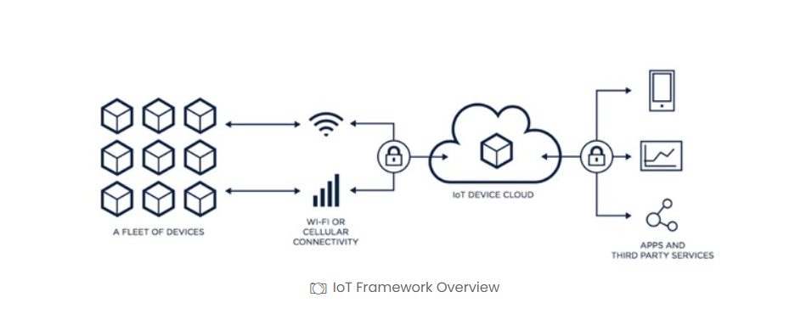

Figure 13 IoT Frameworks

The IoT framework is a very important element of technology in the modern world, finding application in almost every sector. For instance, one of the major applications of the IoT is in the designing of smart homes.

The IoT framework concept is also applied in the designing of different physical objects, such as thermostats, electrical devices, security and alarm systems, as well as vending machines, among many other objects.

(iotdunia, 2020)

**Main Components of the Internet of Things Framework**

*\*The IoT Framework is comprised of four major components, as discussed below*

**a) Device Hardware**

The device hardware component of the IoT framework requires some basic knowledge on architecture. The user is also required to have an idea on the working of the different micro-controllers, as well the sensors.

Examples of hardware devices that form part of this IoT framework component are sensors, micro-controllers and controllers.

**b) Device Software**

In order for the device software of the IoT framework to function properly, the included writing applications are required to configure the controller, then operate them remotely. The user is required to have a basic understanding of how an API works inside the micro-controllers, as well how libraries are usually made for programming**.**

**c) Communication and Cloud Platform**

The cloud platform is one of the most crucial parts of the IoT framework. It calls for the basic knowledge of all communication, whether wireless or wired. The user is also required to have a good understanding of IoT integration, as well as the working of the cloud technology.

In summary, we can say the communication and Cloud Platform of the IoT Framework is where all communications happen.

**d) Cloud Application**

The cloud application is a type of software program, which mainly consists of components that can be accessed quite easier and faster. These components can be either local or even cloud-based. The cloud application works to improve the system, such that its maximum potential is realized.

In other words, the cloud application can be defined as the written application of an IoT framework, that binds all the local hardware devices, as well as the cloud-based devices.

(iotdunia, 2020)

**Some IoT Frameworks:**

**KAA IoT:** Kaa IoT is one of the most effective and rich Open Source Internet of Things Cloud Platforms, where anyone can freely implement their smart product concepts. You can manage an N number of devices connected to each other with cross-device interoperability on this platform. You can monitor your machine in actual time by providing and configuring remote devices. Kaa enables information exchange between linked devices, the IoT Cloud, information and visualization systems, as well as other elements of IoT Ecosystems

**Cisco IoT Cloud Connect:** Cisco IoT Cloud Connect provides robust, automated, and highly secure connectivity for the enterprise. IoT data management is done by the Cisco Kinetic IoT platform to extract, move and compute the data. As Cisco is very famous for its security services, it protects IoT deployment against threats with a secure IoT architecture.

**ZETTA IoT:** Zetta is nothing but a server-oriented platform developed based on the REST, NodeJS, and the Siren hypermedia-API-strip flow-based reactive programming philosophy. After being abstracted as REST APIs they are connected with cloud services. These internet services include tools for visualizing machine analytics and support such as Splunk. It builds a gero-distributed network through connectivity with systems like Heroku to endpoints like Arduino and Linux hackers.

**Oracle IoT:** We surely include Oracle, a worldwide software company known to offer its top level of solutions in database management, and business software, as we compare the top Internet-of-Things platforms. Oracle offers its flexible environment outstanding company possibilities to create company applications. Oracle supports the processing and builds large-scale IoT networks with very wide data. The use of advanced security systems to protect IoT systems against external threats is another worth mentioning. Since these systems usually have different devices, some of which have no security tool, it is not sufficiently justifiable to implement centralized security measures.

**Google Cloud Platform – IoT framework:** Things can be done by Google. Google Cloud is one of the best IoT systems available today with its end-to-end platform. Google stands out from the others because it can process the large quantity of information using Cloud IoT Core. Due to Google’s Cloud Data Studio and Big Query you get advanced analysis. With the help of Google Cloud Platform, you can accelerate your business and with that, you can speed up your device.

**Ayla Network – IoT framework:** Ayla networks have developed their platform as a solution for enterprises. Agile Ayla networks have been established to support customers with the smooth establishment of services, not only to develop the product. In addition to the Ayla agile platform, AMAP is an agile mobile app platform from Ayla that develops and guides consumers through app development.

**Amazon Web Services (AWS) IoT framework:** Amazon Web Services (AWS) is an IoT platform provided by Amazon. This IoT platform provides cloud computing, database, and security services through the AWS Console. There are so many other services such as Regions, Availability Zones, and Virtual Private Clouds (VPCs). It helps to ease out the improving durability, distribution, availability of the application. It provides Registry for recognizing devices, Secure Device Gateway, Compatible Software Development Kit for devices which AWS partnered with HW manufacturers like Intel, Texas Instruments, Broadcom and Qualcomm.

(Pedamkar, 2020)

## 3. IoT Hardware:

In the Internet of Things, hardware comes in many forms, whether the underlying processors control the phones, the sensors collecting information from the physical world, or the edge machines processing and analyzing the data. At the heart of any wired venture is IoT hardware and the technical capabilities of these boards have only become more important as the Internet of Things has developed. But, because of the sheer number of design boards and modules in the room, choosing the right IoT hardware for a project can be daunting. In this article, we will look at different aspects of IoT hardware and see how these devices communicate data to the internet.

**IoT Hardware Devices:** The building blocks of an IoT device are remarkably similar, whether undertaking projects related to the wearable device, an integrated lighting system, or even a jet engine. Wireless sensor node consists of three major hardware components they are sensors, microcontrollers, and communication medium.

**a. Sensors**: Sensors are the most critical hardware in IoT applications and are used to gather information from the surroundings. These systems are made up of power management modules, RF, energy and sensing modules. Communication from Wi-Fi, Bluetooth, transceiver, BAW, and duplexer is managed by an RF module.

**b. Microcontrollers**: A microcontroller is a device in a single integrated circuit devoted to executing a single task and running an application. This contains programmable peripherals for contains programmable, memory unit, and a CPU. Microcontrollers are designed primarily for embedded applications and are widely used in remotely operated electronic devices such as mobile phones, washing machines, microwaves, and cameras.

**c.** **Other IoT hardware:** Smart wearable devices such as smart memory, glasses, rings, and shoes are examples of IoT hardware. Smart devices allow us to access more of the content and resources that we love and create a new approach to collaboration as part of an IoT network. Desktop, mobile phones, and tablets are standard command center and remains an integral part of IoT application. Other network distribution devices like switches, hubs, and routers act as a key connector in IoT application.

**IoT Hardware Providers**

In today’s market, one can find many IoT hardware providers who will be able to provide the required hardware-based up on the project requirement. Let’s take a quick overview of a few of the hardware providers.

* Adafruit offers DIY electronic hacking courses online and provides a space to learn. ‘Adafruit Feather’ is a production line of boards designed for fly prototyping. This production line includes a wide catalog of accessories that speed up IoT application development.
* Arduino is the omnipresent name in the space for electronic development. The company offers a range of open-source development kits, billing software, and microcontrollers.
* Lantronix is a company that offers Infrastructure, modules and gateway kit to support connectivity between IoT applications. This California based company has recently launched advanced gateways based on XP200 industrial standard.
* Espressif is well known for its low energy consuming IoT hardware applications for Wi-Fi and Bluetooth. Espressif is popular for its processors, modules, and production boards series ESP826. Most industry-wide development boards are working on Espressif chipset.

(Priya Pedamkar, 2020)

## 4. IoT APIs:

The application program (or programming) interface, or API, is arguably what really ties together the connected “things” of the “internet of things.” IoT APIs are the points of interaction between an IoT device and the internet and/or other elements within the network.

As API management company Axway puts it, “APIs are tightly linked with IoT because they allow you to securely expose connected devices to customers, go-to-market channels and other applications in your IT infrastructure.”

(Kelly Hill, 2016)

In general, API is the term referring to standard framework collection, protocols, and resources dictating the generic web and mobile application. It defines the communication rules that every application component must follow while exchanging information with each other.

APIs that are used in the creation of IoT solutions are known as IoT APIs. They are the web services application programming interfaces. They work in a similar fashion and make seamless data flow, with HTTPbeing the medium. Using the IoT API lets developers design advanced applications that are easy to integrate with other web services.

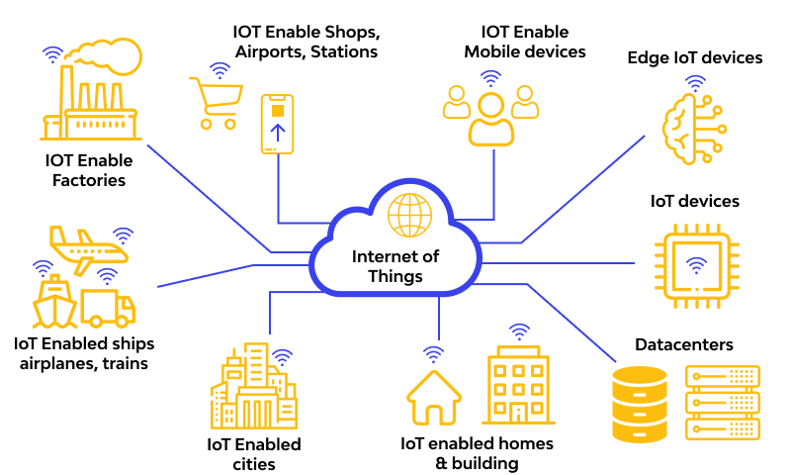

Figure 14 IoT APIs

**Why are IoT APIs important?**

“APIs are the market enabler, and ‘internet of things’ devices would be useless without them. By exposing data that enables multiple devices to be connected, APIs provide an interface between the internet and the things to reveal previously unseen possibilities,” said Chris O’Connor, IBM’s GM for IoT, in a blog entry. “In the year to come, the power and importance of APIs will be at the forefront of the conversation around enabling—and more important—monetizing the ‘internet of things.'”

(Kelly Hill, 2016)

More often than not it is becoming very common for developers to come across some reference to APIs, or application programing interfaces. All the big giant tech firms such as Google, Microsoft, Facebook and twitter all have their own APIs for developers to integrate their projects into one another with ease.

If you work with APIs, then you should already know how important they are in technology today. But for the rest, you may wonder, "What are APIs and why do we need them so much?"

In the simplest terms, APIs are a set of requirements that determine exactly how applications can talk to each other. APIs have been around for many years; whenever you use your everyday computer or smartphone, APIs make it possible to transfer information between programs such as copying and pasting from one application to another, which is done using a system-level API in the OS.

On the web, APIs allow big everyday services such as Google maps, Facebook or twitter to integrate with other applications features. Take a moment and think about the way TripAdvisor works, by displaying local hotels, restaurants and attractions on a google map using its own web data, or mobile games that allow users to invite their friends through Facebook or Google+.

APIs accomplish all of this by revealing some of a program's internal code to the outside world in a very restricted limited ability to avoid any security mishaps. That makes it possible for applications to share data and take actions on the others behalf without requiring developers to share all their code. Code-sharing on a large scale would be very unethical for most programmers to consider and also be inefficient.

This is also a true statement for many open-source applications. Nobody has the time to check all the code for someone else's applications just to use one function of the application. Every programmer has a different method of writing and annotating code; and there could be millions of lines of code to look through!

APIs simplify this issue by limiting outside program access to a specific set of features, which are often requests for data for a particular service. The best way to think of this process is doors and windows, where every door opens to a different house and every house is different. APIs clearly define exactly how you can interact with the rest of the world, ultimately with the purpose of saving a massive amount of time, resources and the possibility of legal entanglements.

(Maker.io Staff, 2016)

**Different Types of APIs in IoT services**

APIs based around the IoT are mostly web service APIs and they can come in different forms such as SOAP, REST or XML/JSON. A web service is a piece of software, or a system, that provides access to its services via an address on the web. This address is known as a URL. This web service offers its information in a format that other applications can understand or parse through. Examples of popular web service APIs are Flickr API, Google maps API and Google maps web services API. When an application or client wants to communicate with a web service, the application sends back an HTTP request to the client in response. In the response request, much of the information is passed in the URL itself as paths or parameters.

In addition to the standard URL, HTTP requests and responses will include information in the header and the body of the message. Request and response headers include different various types of metadata, such as the browser being used or the content type. The body includes additional data in formats such as XML and JSON.

**SOAP – Simple Object Access Protocol:** SOAP is a protocol that defines the method of communication between the client and the server. The transfer of data is done in a XML format. A SOAP web service publishes a definition of its interface in a machine-readable document using web services definition language.

**API Management:** API management is an umbrella in which a collections of solutions are grouped together; such as gateways, security and access management. API management also includes developer registration and API key control. An API service will need to grant developers who enable the connecting of devices to APIs the authority and associated key to do this whilst retaining the right to remove access when necessary.

A good example of a web service that provides good API management is IFTTT service (if this then that). IFTTT gives users creative control over 300 devices and application services using something called recipes. Recipes are simple connections between products and apps. Just recently, BMW car manufacturing group has created their own channel which allows users to get the most out of their car. It allows drivers to trigger events when you park, speed or arrive at a destination, and furthermore you can receive custom notifications straight to your in-car dashboard.

(Maker.io Staff, 2016)

**Some APIs for the Internet of Things**

IoT APIs allow applications to read sensors and analyze smart city or smart campus data, automate home appliances, utilize voice commands, manage proximity beacons, automate smartcars, manage edge computing, manage manufacturing and industrial equipment, and so much more.

**Garmin Health API:** Garmin Health API enables developers to leverage health and activity data collected from Garmin wearables. There are methods available to collect data about steps, sleep, calories, heart rate, stress, intensity minutes, body composition and more. Thirty types of activity are monitored including running, cycling, paddle boarding, swimming and more.

**Google Assistant API:** Google Assistant can be embedded into devices to enable voice control, hotword detection, natural language understanding, and other intelligence services. The Google Assistant APITrack this API provides a way to manage and converse with devices. Google Assistant enables voice control over phone applications, speakers, smart displays, automobiles, watches, laptops, TV, and other Google Home devices (including Nest). Users can do Google searches about weather, sports, traffic, news, flights, add reminders, manage tasks, control smart home devices, and much more with this API and SDKs.

**Withings API**: Withings is a company focusing on the development of connected measuring devices, such as scales and blood pressure monitors, that can send health information directly to the internet. Withings Body metrics Services API (WBS API)Track this API is a set of webservices allowing developers and third parties limited access to users' data about activity, heart ECG (or EKG). sleep cylces, and more.

**Ubidots API:** Ubidots offers a platform for developers that enables them to easily capture sensor data and turn it into useful information. The Ubidots platform can send data to the cloud from any Internet-enabled device. Developers can then configure actions and alerts based on real-time data and visual tools. The Ubidots REST APITrack this API allows users to read and write data to the resources available, with methods for data sources, variables, statistics, events and insights.

**Apple HomeKit:** Apple's HomeKit provides a platform for devices, apps, and services to communicate. Utilizing Siri, iPhone users can control supported devices in their home. Lights, thermostats, garage doors, etc. could all be controlled by voice. Apple HomeKit API is accessible via the Apple iOS8 SDK.

( Joy Culbertson, 2020)

## 5. IoT Tools

The scope and development of IoT are going to evolve in the coming years ultimately influencing people and companies to seek the top IoT product solutions. IoT development tools are created for tailing IoT applications across various networks and managing diverse updates to test how app changes can affect hardware responses.

**Microsoft Azure IoT kits**

Microsoft Azure created a team by coordinating with Adafruit for building six IoT kits that come Azure Certified for the need of IoT developers having single-board PCs, actuators, and sensors. Generally, developers can make use of the WiFi boards, SD cards, sensors, and colored LEDs inside the kits. Some of the IoT kits from Azure are intended for the need of top IoT product development by experts. Those who are beginners or have intermediate knowledge can try the Adafruit Raspberry Pi Kit, Adafruit Feather M0 Kit, and SparkFun Thing Dev Kit.

**Arduino (IDE)**

Adruino is a top IT company based in Italy famous for building microcontroller boards, and interactive kits and objects that are reputed as the most preferred IDEs among other IoT development tools. Arduino crafted a full-blown, optimized, and mature platform for interconnecting diverse hardware systems. Arduino provides a full IoT package that is enriched with many top examples and libraries that supports the industry-grade IoT app development projects.

Arduino offers IoT packages enriched with library support for top industry-grade IoT app development projects. Arduino is easy-to-use to implement strategies that any beginner can adopt and start with it.

**Raspbian**

Raspbian IoT IDE was built for the Raspberry Pi board offered by IoT tech specialists. With more than 35,000 packages and various examples of rapid installation that come with the use of pre-compiled software make it an important IoT development tool. Maybe Raspbian’s greatest quality is that it’s under constant development and has widened reach for computing so users receive maximum benefits.

**DeviceHive**

DeviceHive is an open-source machine to machine communication framework that was launched in 2012. DeviceHive is considered as one of the most preferred IoT application development platforms because it has a cloud-based API that anybody can control remotely and independently of network configuration.

The same applies to its management portal, protocols, and libraries. DeviceHive works best with applications that address security, sensors, automation, and smart home technology. As a bonus, DeviceHive’s website includes support and references from its community and online blog resources.

**OpenSCADA**

OpenSCADA is a tool that’s part of the SCADA project represented by Eclipse IoT industry groups. It is well-known for its security and flexibility having a modern design. OpenSCADA supports editing and debugging and comes with front-end apps, back-end applications, libraries, interface apps, and configuration tools. The set of diverse tools can be combined with the development of advanced IoT apps. Just like the other IDEs, OpenSCADA supports diverse programming languages and consists of sub-projects including Utgard, Atlantis, Orilla, and others.

**Home Assistant**

Home Assistant is aimed at home automation and functions on the Python-based coding system. It’s an open-source tool whose IoT system is controlled with desktop browsers and mobile. Home Assistant is known for its frictionless operations, privacy standards, and security. The software can support any systems that are running on Python 3. However, it lacks cloud computing and its ability to secure data is a significant disadvantage.

**DeviceHub**

DeviceHub is an integrated solution that offers a combination of business intelligence and cloud integration for delivering hardware and web technologies. Usually, the kit is offered as a Platform as a Service (PaaS) that allows software developers to use its power for the cause of IoT app development. It’s especially beneficial for enterprise bodies who want to rebrand and install software for the need of deploying enterprise apps using Virtual Private Cloud. DeviceHub has achieved success in the fast going building of fleet management systems, smart vending machines, and wearable software.

(Patrick R , 2020)

## Determine a prolem and IoT solution:

1. **Scenario:** Temperature and humidity, and Light diagnosis based on IoTs.
2. **Solution:**

Under climate change, making the environment increasingly uncomfortable and affecting human health, creating conditions for bacteria to grow more with climate changes. So we thought and decided to design an IoT application system that can control and adjust the temperature, humidity and light to maintain it at a stable default value by adjusting the temperature. With internet-connected devices such as fans, lights and devices in the system will be connected to each other via the Internet and managed by users with an application on the phone called Blink. Under the control of the user, all data parameters will be sent to an application on the user's phone through Blynk so that it can be reviewed and managed through its application. User can control Adjust the temperature as needed, for example, when the temperature is too high, the user can start the fan by clicking a button on the app with internet connection to turn on the fan to reduce the temperature in the room or turn off the fan.

Benefits When applying IoT in the system of this scenario for a number of reasons

Firstly, it saves time and cost, and human effort.

Second, It ensures the most accurate calculated value.

Third, it offers greater efficiency in work performance and more reliable results through diagnostics and sensing.

Finally, through sensors, people can know the exact data and provide the right efficient solutions tailored to meet the user's requirements when using the systems through the adopt IoT solutions and bring more benefits to consumers

User can manage and adjust humidity automatically or manually through mobile app and that mobile device will warn about humidity if too high or too low e.g., if humidity is too low, it will report low humidity. Thereby users can adjust the air conditioner to be suitable for the surrounding environmental conditions. In addition, the system can also manage and evaluate the light quality situation and adjust the brightness or darkness in accordance with the current conditions of the room to ensure good room lighting conditions for people's health.

1. **System and function diagram:**

**Framework:**

|  |  |
| --- | --- |
| **Smart App** | Blynk App (Mobile App) |
| **Connectivity** | API, TCP/IP |
| **Sensors** | Temperature sensor, Humidity sensor, Light Sensor  Network: Network (TCP/IP), Wifi Viettel |
| **Product Infrastructure** | Hardware: Ardunio Uno R3  Sorfware: Blynk Server, Blynk API, Ardunio |

**System Diagram:**

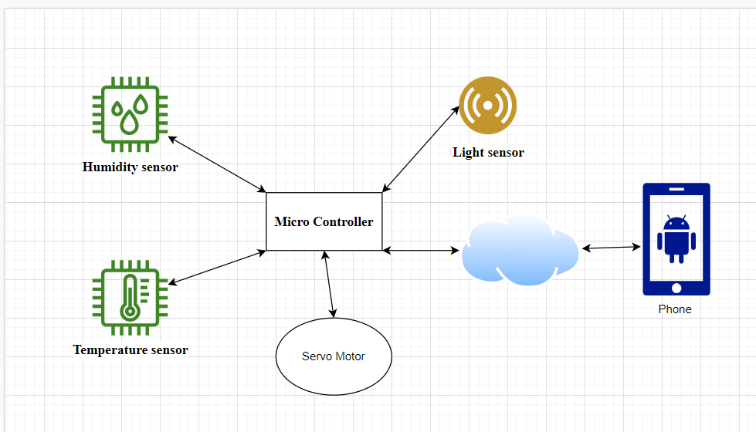

Figure 15 System Diagram

**Hardware intended to be used:**

**Ardunino Uno:**

Arduino Uno is a microcontroller board based on the ATmega328P (datasheet). It has 14 digital input/output pins (of which 6 can be used as PWM outputs), 6 analog inputs, a 16 MHz ceramic resonator (CSTCE16M0V53-R0), a USB connection, a power jack, an ICSP header and a reset button.

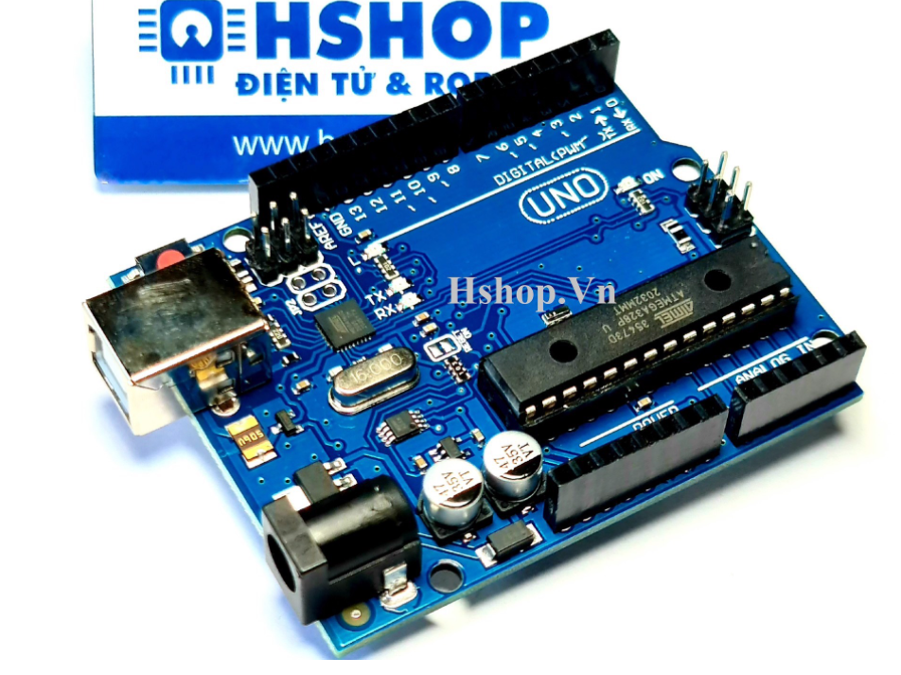

Figure 16 Ardunio Uno R3[8]

**Specifications:**

* Main control chip: ATmega328P
* Chip feeder and UART interface: ATmega16U2
* Circuit power supply: 5VDC from USB port or external source plugged from DC round jack
* Number of Digital I/O pins: 14 (of which 6 are capable of outputting PWM pulses).
* Number of PWM Digital I/O pins: 6
* Analog Input Pins: 6
* DC Current per I/O pin: 20 mA
* DC Current 3.3V pin: 50 mA
* Flash Memory: 32 KB (ATmega328P), 0.5 KB for bootloader.
* SRAM: 2KB (ATmega328P)
* EEPROM: 1 KB (ATmega328P)
* Clock Speed: 16 MHz
* LED_BUILTIN: 13
* Dimensions: 68.6 x 53.4 mm

**Servo RC Motor 9G:**

9G RC Servo motor is small in size, which is most used for making small models or traction mechanisms that don't require heavy force, 9G RC Servo motor has fast response speed, gears are Made of plastic, care should be taken when lifting heavy loads because it can damage gears, 9G RC Servo motor has a built-in motor driver driver inside, so the rotation angle can be easily controlled by the wide dispatch method. PWM pulses.

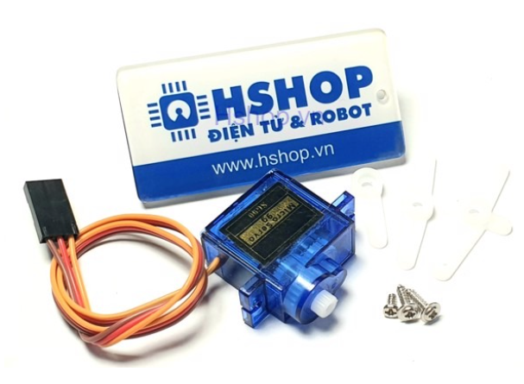

Figure 17 Servo RC Motor 9G[9]

Specifications:

* Operating voltage: 4.8-5VDC
* Speed: 0.12 sec/ 60 degrees (4.8VDC)
* Traction: 1.6KG.CM
* Dimensions: 21x12x22mm
* Weight: 9g.

**HDT - Temperature Humidity Sensor**

This is a digital temperature and humidity calibration module with onboard sensor DHT11. It can be used to detect ambient temperature and humidity, through the standard single-wire interface.

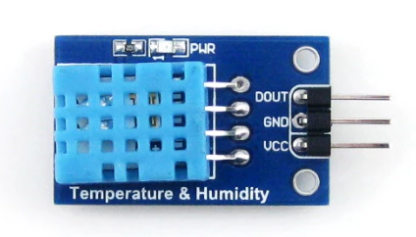

Figure 18 HDT - Temperature Humidity Sensor[10]

**Specifications**

* Temperature
* Resolution: 1°C
* Accuracy: °C
* Measuring range: 0°C ~ 50°C

**Humidity**

* Resolution: 1% RH
* Accuracy: ±5% RH (0 ~ 50 °C)
* Measuring range: 20% RH ~ 90% RH (25°C)
* Operating voltage: 3.3V ~ 5.5V

**Recommended storage conditions**

* Temperature: 10°C ~ 40°C
* Humidity: 60% RH or below

**Light Sensor**

Photodiod Light Sensor uses Photodiod instead of photoresistor to sense light, so it gives high accuracy and stability, the sensor has built-in Opamp for both Digital and Analog signal outputs, very easy to use suitable for applications of light and dark sensing, light intensity sensing,...

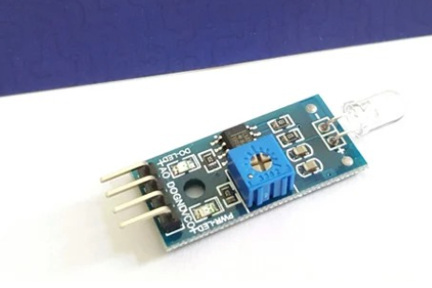

Figure 19 Light Sensor[11]

* **Specifications:**

**•** Power: 3.3 -> 5VDC

• Use Photodiode for high accuracy.

• Output fine-tuned digital signal by on-board rheostat or analog very easy to use.

• Dimensions: 30 x 16mm

|  |  |
| --- | --- |
| A0 | Analog signal output |
| DO | Digital signal output |
| VCC | Source 3.3 ~ 5VDC |
| GND | Mass |

# References

Joy Culbertson, 2020. *https://www.programmableweb.com/.* [Online]   
Available at: https://www.programmableweb.com/news/10-top-apis-internet-things/brief/2020/03/29

avsystem, 2019. *what-is-iot-architecture.* [Online]   
Available at: https://www.avsystem.com/blog/what-is-iot-architecture/

geeksforgeeks, 2020. */architecture-of-internet-of-things-iot/.* [Online]   
Available at: https://www.geeksforgeeks.org/architecture-of-internet-of-things-iot/

geeksforgeeks, 2021. */5-layer-architecture-of-internet-of-things/.* [Online]   
Available at: https://www.geeksforgeeks.org/5-layer-architecture-of-internet-of-things/

geeksforgeeks, 2021. *characteristics-of-internet-of-things/.* [Online]   
Available at: https://www.geeksforgeeks.org/characteristics-of-internet-of-things/

Gillis, A. S., 2020. *definition/Internet-of-Things-IoT.* [Online]   
Available at: https://internetofthingsagenda.techtarget.com/definition/Internet-of-Things-IoT

iotdunia, 2020. *what-is-iot-framework-list-top-10-open-source-iot-frameworks/.* [Online]   
Available at: https://iotdunia.com/what-is-iot-framework-list-top-10-open-source-iot-frameworks/

Kelly Hill, 2016. */internet-of-things/what-is-an-iot-api-tag6-tag99.* [Online]   
Available at: https://www.rcrwireless.com/20161018/internet-of-things/what-is-an-iot-api-tag6-tag99

Khanna, R., 2016. *https://www.hindawi.com/.* [Online]   
Available at: https://www.hindawi.com/journals/jece/2017/9324035/

Maker.io Staff, 2016. *how-important-are-apis-in-iot.* [Online]   
Available at: https://www.digikey.com/en/maker/blogs/how-important-are-apis-in-iot

Maker.io, 2016. */how-important-are-apis-in-iot.* [Online]   
Available at: https://www.digikey.com/en/maker/blogs/how-important-are-apis-in-iot

Patrick R , 2020. *10-best-iot-development-tools-technologies-2020.* [Online]   
Available at: https://www.iotforall.com/10-best-iot-development-tools-technologies-2020

Pedamkar, P., 2020. */iot-tools/.* [Online]   
Available at: https://www.educba.com/iot-tools/

Priya Pedamkar, 2020. *https://www.educba.com.* [Online]   
Available at: https://www.educba.com/iot-hardware/

Ranger, S., 2020. *What it means for IoT.* [Online]   
Available at: https://www.zdnet.com/article/what-is-the-internet-of-things-everything-you-need-to-know-about-the-iot-right-now/

trendmicro.com, 2021. *definition/internet-of-things.* [Online]   
Available at: https://www.trendmicro.com/vinfo/us/security/definition/internet-of-things

1. https://www.i-scoop.eu/internet-of-things-iot/internet-of-things-what-definition/
2. https://mindmajix.com/top-10-real-world-iot-applications
3. https://www.finoit.com/blog/role-of-internet-of-things-for-smart-cities-challenges-of-iot/
4. https://mindmajix.com/top-10-real-world-iot-applications
5. https://data-flair.training/blogs/iot-applications-in-agriculture/
6. https://www.avsystem.com/blog/what-is-iot-architecture/
7. https://www.geeksforgeeks.org/5-layer-architecture-of-internet-of-things/
8. https://hshop.vn/products/arduino-uno-r3
9. https://hshop.vn/products/dong-co-rc-servo-9g
10. https://vi.aliexpress.com/item/2041891342.html
11. https://hshop.vn/products/cam-bien-anh-sang-photodiod